**BANK LOAN REPORT QUERY DOCUMENT**

**A.BANK LOAN REPORT|SUMMARY**

**KPI’S:**

**Total Loan Applications**

**SELECT COUNT(id) AS Total_loan_Applications FROM bank_loan_data**



**MTD Loan Applications**

**SELECT COUNT(id) AS MTD_Total_loan_Applications FROM bank_loan_data**

**WHERE MONTH(issue_date) = 12 AND YEAR(issue_date) =2021**



**PMTD Loan Applications**

**SELECT COUNT(id) AS PMTD_Total_loan_Applications FROM bank_loan_data**

**WHERE MONTH(issue_date) = 11 AND YEAR(issue_date) =2021**



**Total Funded Amount**

**SELECT SUM(loan_amount) AS Total_Funded_Amount FROM bank_loan_data**



**MTD Total Funded Amount**

**SELECT SUM(loan_amount) AS MTD_Total_Funded_Amount FROM bank_loan_data**

**WHERE MONTH(issue_date) = 12 AND YEAR(issue_date) = 2021**



**PMTD Total Funded Amount**

**SELECT SUM(loan_amount) AS PMTD_Total_Funded_Amount FROM bank_loan_data**

**WHERE MONTH(issue_date) = 11 AND YEAR(issue_date) = 2021**



**Total Amount Received**

**SELECT SUM(total_payment) AS Total_Amount_received FROM bank_loan_data**



**MTD Total Amount Received**

**SELECT SUM(total_payment) AS MTD_Total_Amount_received FROM bank_loan_data**

**WHERE MONTH(issue_date) = 12 AND YEAR(issue_date) =2021**



**PMTD Total Amount Received**

**SELECT SUM(total_payment) AS PMTD_Total_Amount_received FROM bank_loan_data**

**WHERE MONTH(issue_date) = 11 AND YEAR(issue_date) = 2021**



**Average Interest Rate**

**SELECT AVG(int_rate) * 100 AS Avg_Interest_Rate FROM bank_loan_data**



**MTD Average Interest**

**SELECT AVG(int_rate) * 100 AS MTD_Avg_Interest_Rate FROM bank_loan_data**

**WHERE MONTH(issue_date) = 12**



**PMTD Average Interest**

**SELECT AVG(int_rate) * 100 AS PMTD_Avg_Interest_Rate FROM bank_loan_data**

**WHERE MONTH(issue_date) = 11**



**Avg DTI**

**SELECT AVG(dti) * 100 AS Avg_DTI FROM bank_loan_data**



**MTD Avg DTI**

**SELECT AVG(dti) * 100 AS Avg_DTI FROM bank_loan_data**

**WHERE MONTH(issue_date) = 12**



**PMTD Avg DTI**

**SELECT AVG(dti) * 100 AS PMTD_Avg_DTI FROM bank_loan_data**

**WHERE MONTH(issue_date) = 11**



**GOOD LOAN ISSUED**

**Good Loan Percentage**

**SELECT**

**(COUNT(CASE WHEN loan_status = 'Fully Paid' OR loan_status = 'Current' THEN id END)*100 / COUNT(id) AS Good_loan_percentage**

**FROM bank_loan_data**



**Good Loan Applications**

**SELECT COUNT(id) AS Good_Loan_Applications From bank_loan_data**

**WHERE loan_status = 'Fully Paid' OR loan_status = 'Current'**



**Good Loan Funded Amount**

**SELECT SUM(loan_amount) AS Good_Loan_Funded_amount FROM bank_loan_data**

**WHERE loan_status = 'Fully Paid' OR loan_status = 'Current'**



**Good Loan Amount Received**

**SELECT SUM(total_payment) AS Good_Loan_Funded_received FROM bank_loan_data**

**WHERE loan_status = 'Fully Paid' OR loan_status = 'Current'**



**BAD LOAN ISSUED**

**Bad Loan Applications**

**SELECT COUNT(id) AS Bad_Loan_Applications FROM bank_loan_data**

**WHERE loan_status = 'Charged Off'**



**Bad Load Funded Amount**

**SELECT SUM(loan_amount) AS Bad_Loan_Funded_amount FROM bank_loan_data**

**WHERE loan_status = 'Charged Off'**



**Bad Loan Amount Received**

**SELECT SUM(total_payment) AS Bad_Loan_amount_received FROM bank_loan_data**

**WHERE loan_status = 'Charged Off'**



**LOAN STATUS**

**SELECT**

**loan_status,**

**COUNT(id) AS Total_Loan_Applications,**

**SUM(total_payment) AS Total_Amount_Received,**

**SUM(loan_amount) AS Total_Funded_Amount,**

**AVG(int_rate * 100) AS Interest_Rate,**

**AVG(dti * 100) AS DTI**

**FROM**

**bank_loan_data**

**GROUP BY**

**loan_status**



**SELECT**

**loan_status,**

**SUM(total_payment) AS MTD_Total_Amount_Received,**

**SUM(loan_amount) AS MTD_Total_Funded_Amount**

**FROM bank_loan_data**

**WHERE MONTH(issue_date) = 12**

**GROUP BY loan_status**

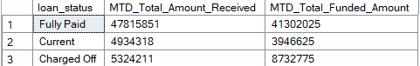

**B. BANK LOAN REPORT | OVERVIEW**

**MONTH**

**SELECT**

**MONTH(issue_date) AS Month_Number,**

**DATENAME(MONTH, issue_date) AS Month_name,**

**COUNT(id) AS Total_Loan_Applications,**

**SUM(loan_amount) AS Total_Funded_Amount,**

**SUM(total_payment) AS Total_Amount_Received**

**FROM bank_loan_data**

**GROUP BY MONTH(issue_date), DATENAME(MONTH, issue_date)**

**ORDER BY MONTH(issue_date)**

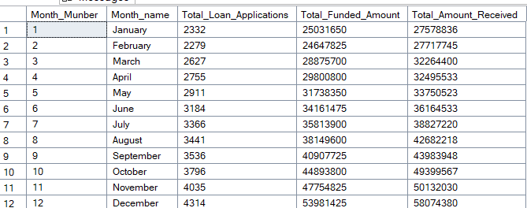

**STATE**

**SELECT**

**address_state AS State,**

**COUNT(id) AS Total_Loan_Applications,**

**SUM(loan_amount) AS Total_Funded_Amount,**

**SUM(total_payment) AS Total_Amount_Received**

**FROM bank_loan_data**

**GROUP BY address_state**

**ORDER BY address_state**

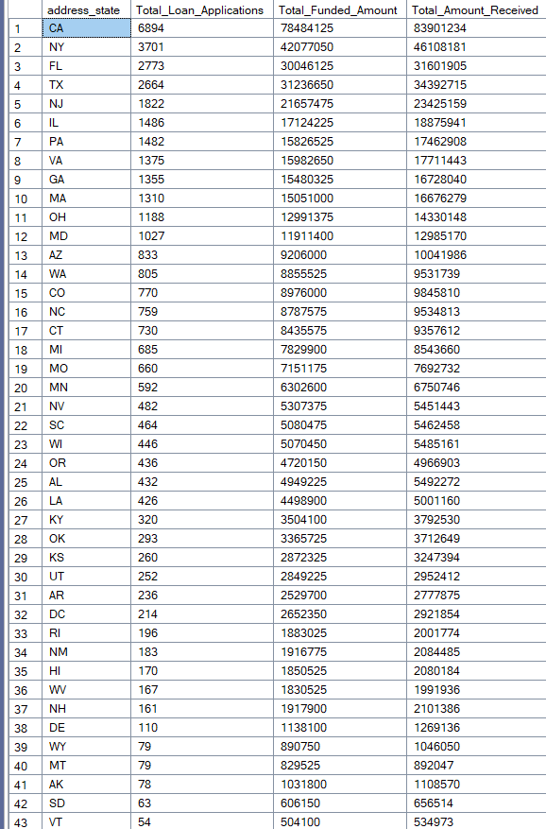

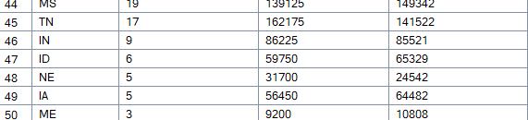

**TERM**

**SELECT**

**term,**

**COUNT(id) AS Total_Loan_Applications,**

**SUM(loan_amount) AS Total_Funded_Amount,**

**SUM(total_payment) AS Total_Amount_Received**

**FROM bank_loan_data**

**GROUP BY term**

**ORDER BY term**

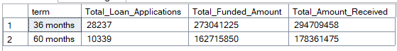

**EMPLOYEE LENGTH**

**SELECT**

**emp_length,**

**COUNT(id) AS Total_Loan_Applications,**

**SUM(loan_amount) AS Total_Funded_Amount,**

**SUM(total_payment) AS Total_Amount_Received**

**FROM bank_loan_data**

**GROUP BY emp_length**

**ORDER BY COUNT(id) DESC**

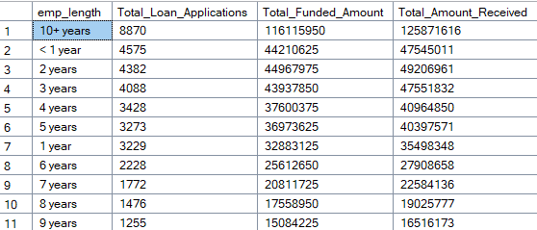

**PURPOSE**

**SELECT**

**purpose,**

**COUNT(id) AS Total_Loan_Applications,**

**SUM(loan_amount) AS Total_Funded_Amount,**

**SUM(total_payment) AS Total_Amount_Received**

**FROM bank_loan_data**

**GROUP BY purpose**

**ORDER BY COUNT(id) DESC**

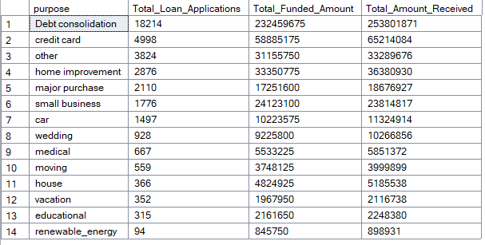

**HOME OWNERSHIP**

**SELECT**

**home_ownership,**

**COUNT(id) AS Total_Loan_Applications,**

**SUM(loan_amount) AS Total_Funded_Amount,**

**SUM(total_payment) AS Total_Amount_Received**

**FROM bank_loan_data**

**GROUP BY home_ownership**

**ORDER BY COUNT(id) DESC**

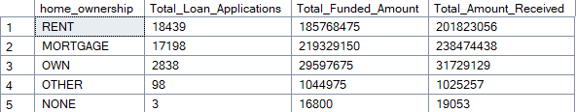

**The results when we hit the Grade A in the filters for dashboards**

**SELECT**

**home_ownership,**

**COUNT(id) AS Total_Loan_Applications,**

**SUM(loan_amount) AS Total_Funded_Amount,**

**SUM(total_payment) AS Total_Amount_Received**

**FROM bank_loan_data**

**WHERE grade = 'A'**

**GROUP BY home_ownership**

**ORDER BY COUNT(id) DESC**

